简介
- 请使用附件内excel内的数据。
- 假定当前时间为2016-08-02

主页：
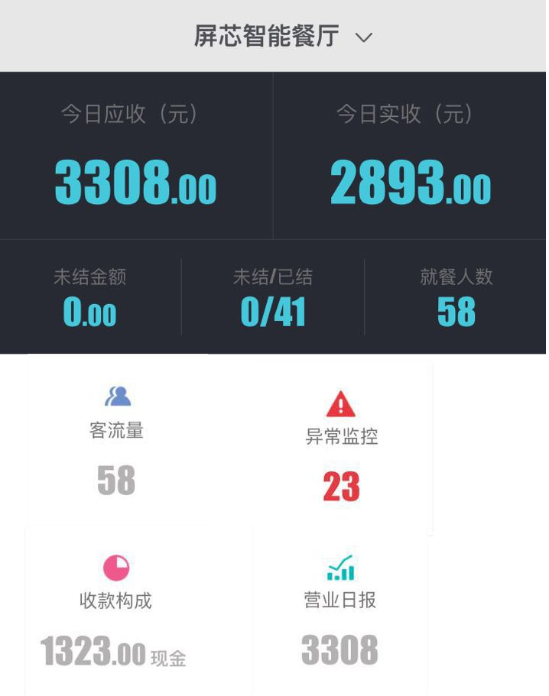
- 黑色区域为固定部分，无交互
  - 今日应收：
    - Select sum(amount) from main_page where date = CURRENT DATE and is_paid = 1
  - 今日实收：
    - Select sum(amount_actual) from main_page where date = CURRENT DATE and is_paid = 1
  - 未结金额
    - Select sum(amount) from main_page where date = CURRENT DATE and is_paid = 0
  - 未结
    - Select sum(order_qty) from main_page where date = CURRENT DATE and is_paid = 0
  - 已结
    - Select sum(order_qty) from main_page where date = CURRENT DATE and is_paid = 1
  - 就餐人数
    - Select sum(ppl_num) from main_page where date = CURRENT DATE and is_paid = 0
- 白色区域为可交互区域
  - 客流量：点击进入客流量页面
    - Select sum(ppl_num) from main_page where date = CURRENT DATE and is_paid = 0
  - 异常监控：点击进入异常监控页面
    - Select sum(order_qty) from main_page where date = CURRENT DATE and discount_type is not null
  - 收款构成：点击进入收款构成页面
    - Select sum(amount_actual) from main_page where date = CURRENT DATE and is_paid = 1 and payment_type = ‘现金‘
  - 营业日报：点击进入营业日报页面
    - Select sum(amount_actual) from main_page where date = CURRENT DATE and is_paid = 1

异常监控
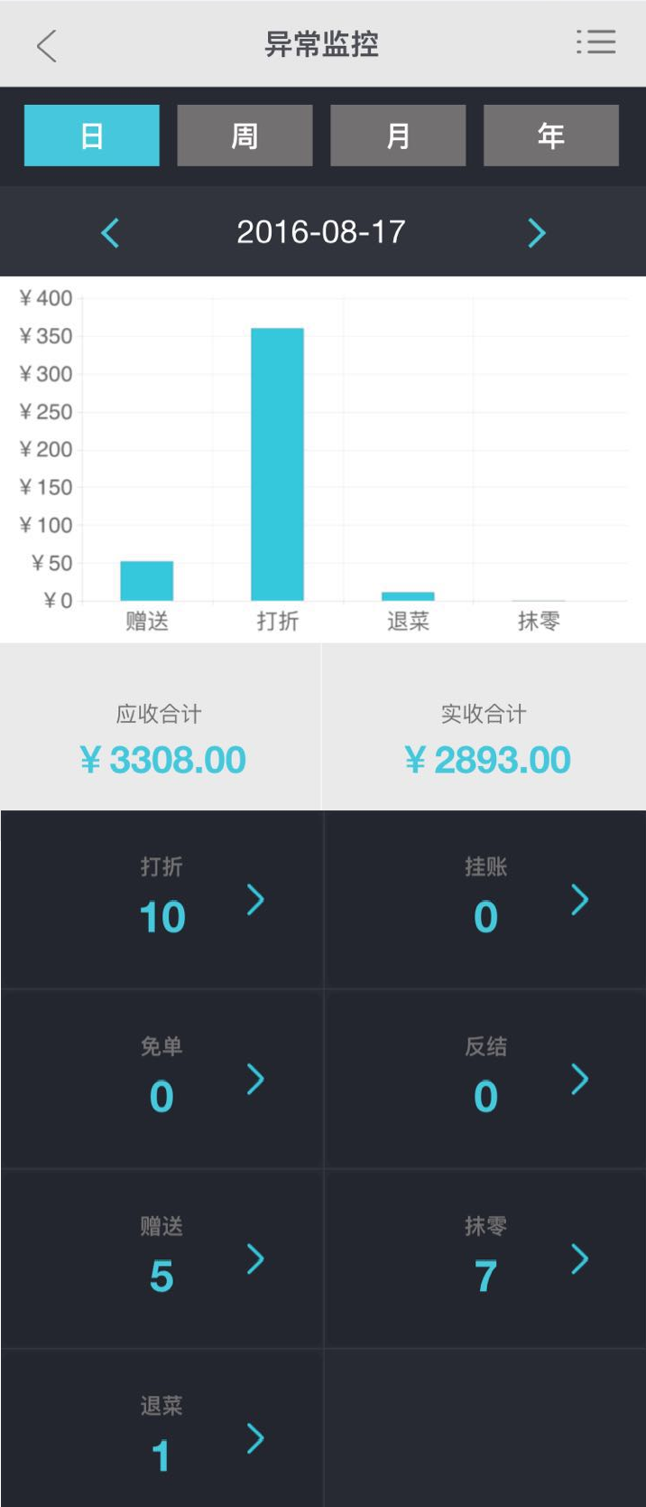

第一部分柱状图，在选定时间范围内根据 discount_type 分类聚合sum(order_qty)
第二部分
  - 应收合计
    - Select sum(amount) from main_page where date between (selected date) and is paid =1
  - 今日实收：
    - Select sum(amount_actual) from main_page where date between (selected date) and is_paid = 1
第三部分黑色区域
在选定时间范围内根据discount type分类sum(order_qty)：共退菜，打折，赠送三类。点击对应方格跳转至异常监控细节页面。

异常监控细节
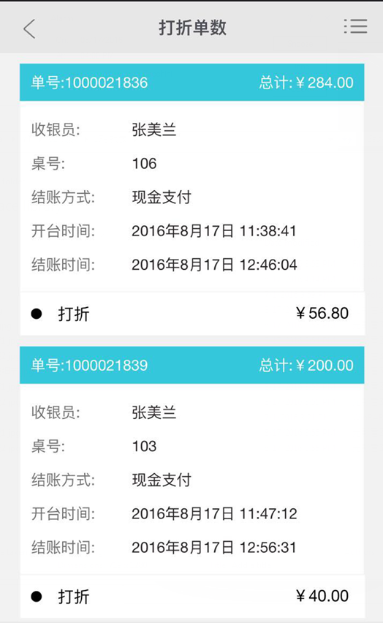
根据上一页面，所选时间和对应点击的异常类型返回结果
Select * from exception where oper_date between selected date and discount_type = selected type
单号：order_id
总计：amount_actual
收银员：operator
桌号：table_no
结账方式：payment_type
结账时间：oper_date
圆点+discount_type
金额为discount _amount

客流量
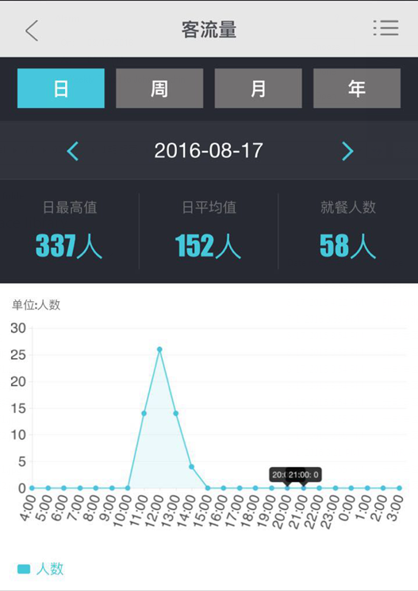
日最高值，与选定时间无关
select max(ppl_num) from (select sum(ppl_num) as ppl_num from main_page group by date) a
日平均值，与选定时间无关
select avg(ppl_num) from (select sum(ppl_num) as ppl_num from main_page group by date) a
折线图，根据选定时间按日-小时，周-星期几，月-日，年-月来展示sum(ppl_num)

营业日报
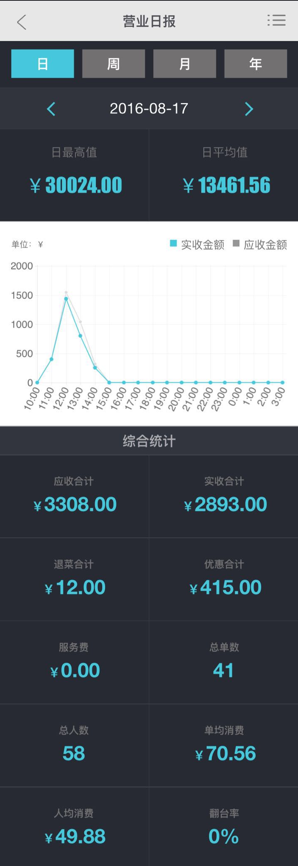
日最高值和日平均值为固定值，不受时间选择影响
select max(amount_actual) from (select sum(amount_actual) as ppl_num from main_page group by date) a
日平均值，与选定时间无关
select avg(amount_actual) from (select sum(amount_actual) as ppl_num from main_page group by date) a
折线图，根据选定时间按日-小时，周-星期几，月-日，年-月来展示sum(amount) –应收金额，sum(amount_actual)- 实收金额
第三部黑色部分综合分析，根据选定时间范围变化
应收合计
Select sum(amount) from main_page where date between selected date and is_paid = 1
实收合计
Select sum(amount_actual) from main_page where date between selected date and is_paid = 1
退菜合计
Select sum(num_back) from main_page where date between selected date and is_paid = 1
优惠合计
Select sum(discount) from main_page where date between selected date and is_paid = 1
服务费——去除，不需要
总单数
Select sum(order_qty) from main_page where date between selected date and is_paid = 1
总人数
Select sum(ppl_num) from main_page where date between selected date and is_paid = 1
单均消费
Select sum(amount_actual)/sum(order_qty) from main_page where date between selected date and is_paid = 1
人均消费
Select sum(amount_actual)/sum(ppl_num) from main_page where date between selected date and is_paid = 1
翻台率——去除，不需要

收款构成
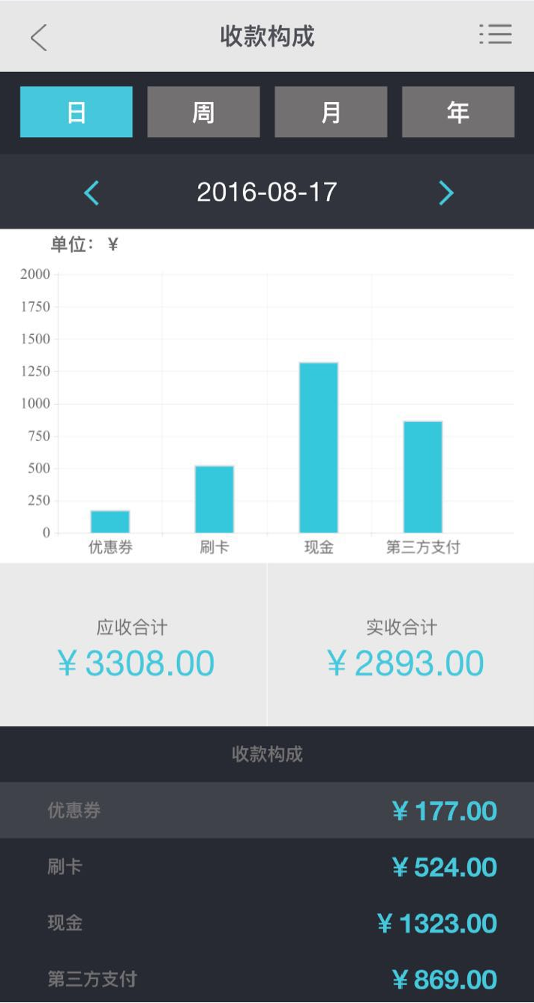
第一部分柱状图，根据所选时间按payment_type聚合sum(amount_actual)，共优惠券，刷卡，现金，第三方四类
第二部分应收合计
Select sum(amount) from main_page where date between selected date and is_paid = 1
实收合计
Select sum(amount_actual) from main_page where date between selected date and is_paid = 1
第三部分收款构成为第一部分柱状图的表格形式

